**Appium Setup for MAC**

* **Java JDK - 1.8+ -** To run the Appium on Mac, user needs to download java jdk 1.8 or higher version. Download link is given below. User can download any version from here after clicking the JDK Download link.

**Download Link** - <https://www.oracle.com/java/technologies/javase-downloads.html>

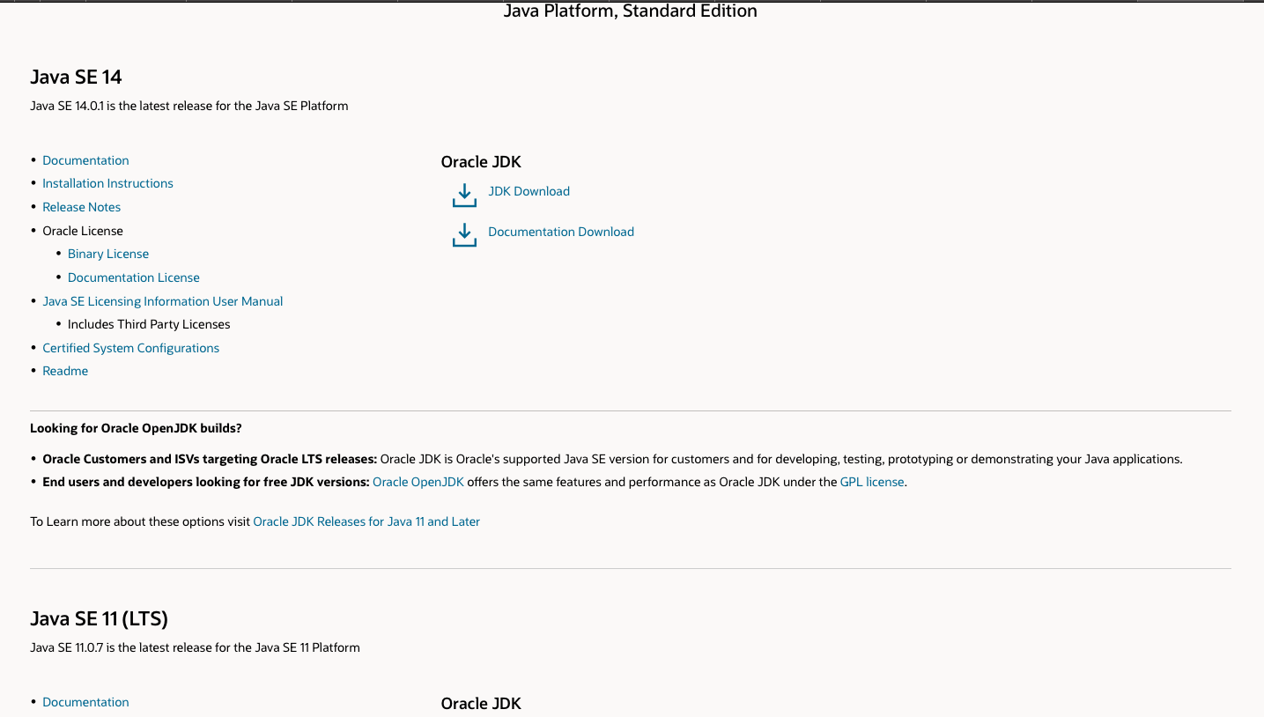

* **Setting the JAVA_HOME and PATH variable into the bash profile** -

1. Open the terminal on the MAC
2. Execute open .bash_profile command to open the bash profile, this command will open the bash profile  
     
   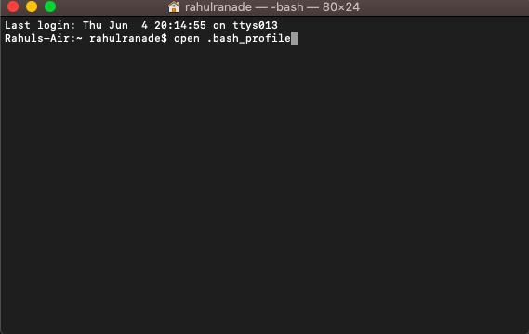
3. Set the JAVA_HOME and PATH variable as mentioned below
4. JAVA_HOME and PATH Variable -   
   export JAVA_HOME= <User Directory>/Java/JavaVirtualMachines/jdk1.8.0_241.jdk/Contents/Home

export PATH=$PATH:$JAVA_HOME/bin  
  
  
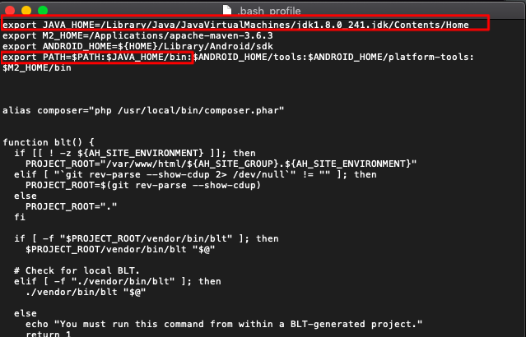

**Download the Android SDK for Emulators -**

1. Browse the URL - <https://developer.android.com/studio> and click the DOWNLOAD ANDROID STUDIO button visible. This will download the android studio on your system.  
     
   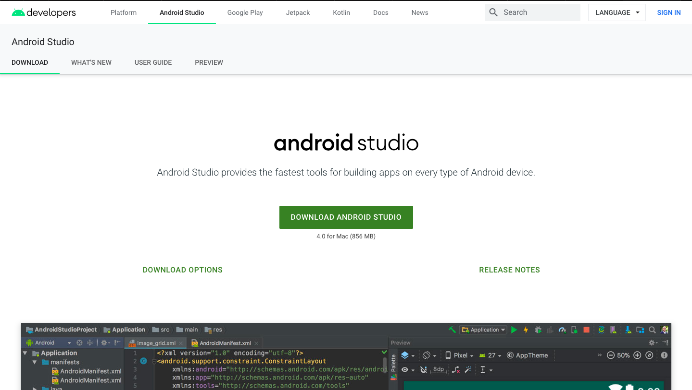

**Download Appium -**

1. There are two ways to download the appium  
   1. Using npm
   2. Using Appium Desktop Client - We are using this approach to configure the appium on the system.
2. Go to <http://appium.io> and click the Download Appium button visible on the page  
     
   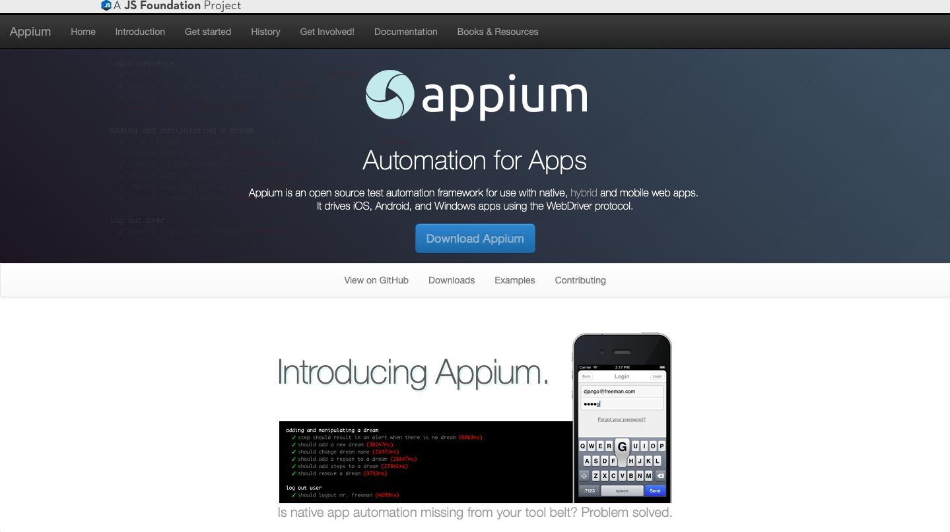
3. This will navigate to the latest appium version available. User is able to select the device from the list.  
     
   